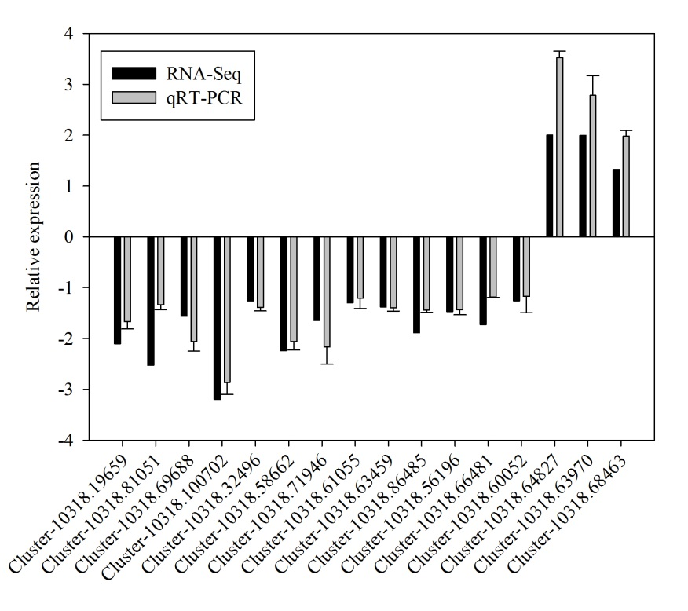

Fig. S2 Validation of RNA-seq results by qRT-PCR. The black bar represents the RNA-seq results; the gray bar represents the RT-qPCR data. Expression change of randomly selected DEGs derived from treated and control plants in “T4 vs H” was indicated by log2-fold change.

